- Answers:
- The choices that have been available for GM/Ford in the last 30 years are the ones within the PPF curve in the graph.
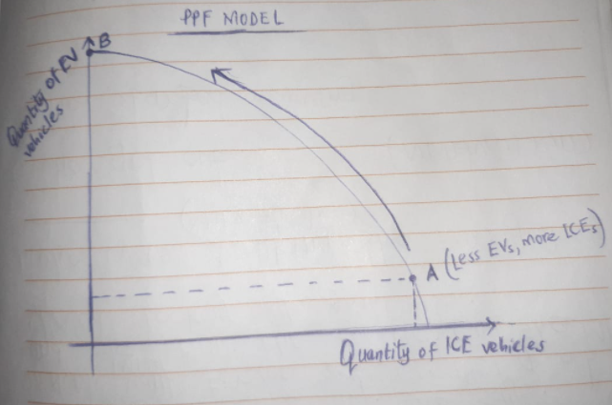
- (Point A shown in the graph above). Explanation: Before 2021, these companies were largely producing ICE vehicles and there were minimal any investments in the production of EVs. It means most resources were used for the production of ICE vehicles.
- Their investment plans will change in that they will allocate all their resources and technology in the production of EVs. Their production possibilities will be moved up the PPF as shown by the arrow.
- Point B is shown in the graph. Means all resources will be used for EVs production. No resource will be available for ICE production.
- A society will always have limited resources (land, labor, capital, and raw materials) and this is what these companies have faced. Would there be enough of these resources, they’d produce all these vehicles. As the economy grows, so do resources. By GM and Ford deciding to invest in the production of EVs, it means they either forego or reduce the quantity of production of ICEs to allocate the resources to EVs. Therefore, the opportunity cost of producing more EVs is literally the cost of producing the foregone ICEs. ICE resources are diverted to the production of EVs and this can be referred to as an allocative efficient point since most consumers would prefer EVs given they are environmentally friendly. As afore mentioned, the companies moves upwards along the PPF curve increasing the opportunity cost of EV by freeing resources. The opportunity cost of producing one more EV car/truck is the marginal cost of EV. When additional increment of resources are added to the production of EV as per the decision of the companies (offsetting ICE resources), the marginal benefit derives from these additional increments will reduce – this is best explained by the law of diminishing returns.
- a. 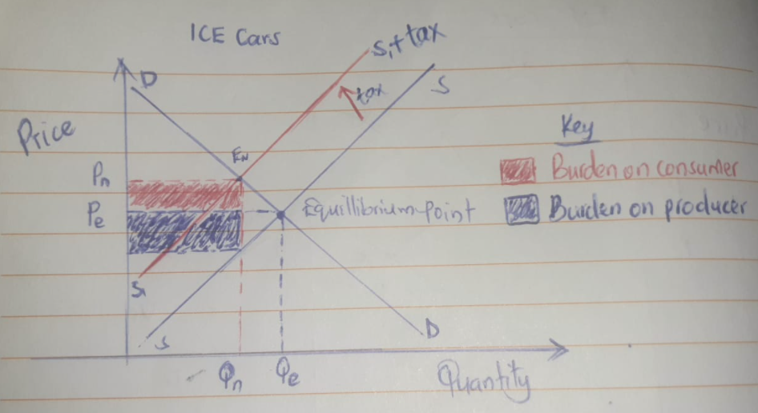
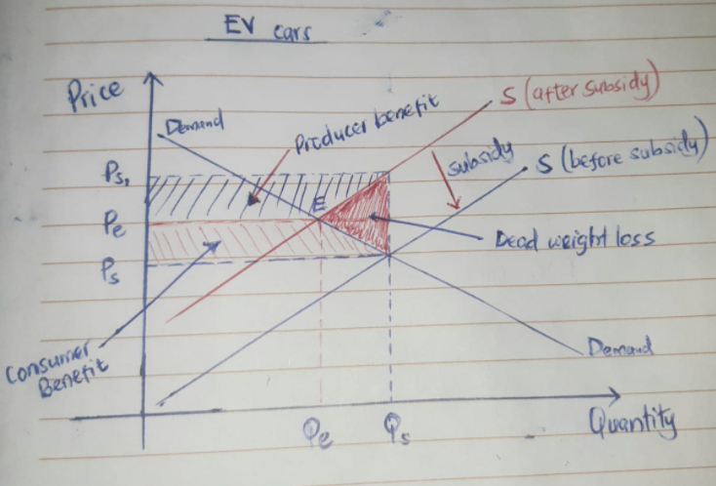

- The imposition of heavy taxes has put some burden on producers and consumers of ICE cars. This burden is shown by the shaded areas on the graph and it is seen in an increased cost of production (lowering supply) and increased purchase price (lowering demand). The market for autos has been shaped by the imposition of subsidies and other incentives to producers. From the graph titled EV cars, the effect of the subsidy is seen to move the supply curve to the right. Price P_{s} is paid by the consumer but P_{s1} is what the seller actually receives. This explains the consumer and producer benefits brought about by the subsidy.
- The article makes it clear that ICEs are overtaxed, this is ideally discouraging their production which is shown by the graph titled ICE cars in part a. above. Additionally, the above graphs shows how the government intervention (subsidy policy) has been put in place to favor or rather to promote the consumption of EVs. From the ICE Cars graph, the government has policed steep taxes on diesel and gas cars and so is their fuels making them expensive to the consumer. This results in reduced demand for ICEs and people are left with the choice of buying EVs which are considerably cheap (the actual price that the consumer pays). The article clearly puts it that Norwegians are not all about being environmentally friendly than any other country, incentives have been implemented for the EV cars increasing their production and this has made them affordable to them. This is all an economic reason for that matter. Considerably, other economic factors that make these cars get preferred are zero value-added tax (its 25% on ICEs), zero registration tax, and zero fuel tax (Duffer et al., 2019).
- New technologies in production
- Parts
- The graphs
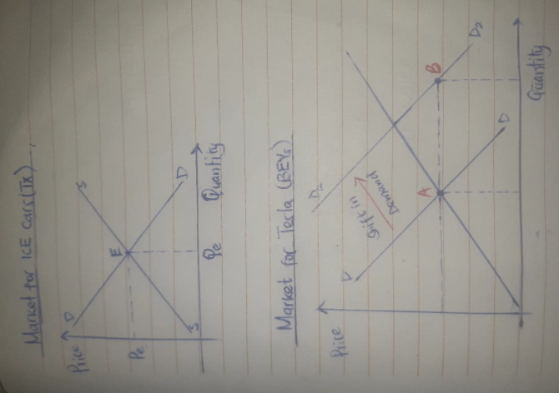
- For the ICE market, the battery technology will not affect the demand or rather the supply of vehicles since these cars don’t use such batteries. They engines are the traditional combustion engines which use petrol, diesel, or gas. For the BEV market, this kind of technology will bring a big effect on the demand of these vehicles. It will shift the demand curve from point A (shown in the graph) to point B. This is to say that more Tesla cars will be purchased at the equilibrium price. The battery technology will make BEVs more effective and thus more appealing to customers.
- Some consumers would still choose ICEs if their governments don’t take a lead in endorsing BEVs. Others are just comfortable with what works for them until they try something else, late adopter and laggard traits can be a big contributor. They have been perpetrators of BEVs who say that this kind of technology might not be as efficient as the ICEs are, so they stick to what they are used to.
- Alternative
- International trade opened markets and countries can now consume what they do not produce locally. For instance in this case, China is endowed with resources to produce alternative energy while U.S., in this case has resource endowment in the production of soybeans. This is another way of saying that China has a comparative advantage or has specialization in the production of alternative energy (produces it at a lower cost than U.S. would) and the U.S. has a comparative advantage in the production of Soybeans. By choosing to import soybeans, China concentrates its resources (opportunity cost) in the production of alternative energy. Importing Soybeans brings maximum benefit to the US as opposed to when they produce it.
- Graphs

- Transition
- Effects of these policies 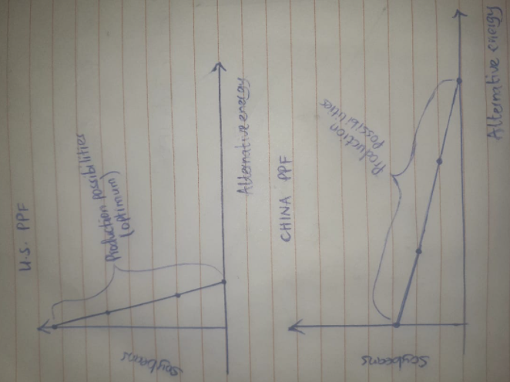
- Financial transfers are attributed to increased income inequality. However, they are good measures that policy analyst can put in place to reduce overdependence amongst citizens. Financial transfers, as the mentioned ones help productive citizens expand their economic productivity and this increases a country’s GDP.
- Subsidies that are paid directly to the autos help maximize production of commodities. This is one way of expanding the economic goals of a country. Subsidies also bring about increase in demand since producers may offer a small price cut on their commodities to promote sales. Again, when subsidies are given, the cost of producing a commodity locally becomes cheap and this opens up such products to competitive foreign prices.
- Imposition of tariffs increases the prices of imported commodities in the local market. For instance, in this case, auto parts manufactured in other countries are sold expensively at the local market and this discourages their demand, and if demand is affected, supply will consequently be compromised. This is a very good strategy that is used to protect infant industries within the country and to allow for economic expansion. This policy reduces any attempts to dump particular commodities in the country.
- I believe that tariffs imposed on auto parts manufactured in other countries would bring the greatest long term increase in economic growth. When the government imposes an import tariff, the cost of importation of that specific commodity increases by the amount of the tariff. That additional marginal cost is meant to discourage imports. Although some imports are good, it is not everything that should be imported. To make sure this is achieved, the government imposes tariffs that protect the environment, combat aggressive trade policies, fortify national defense programs, protect infant industries, and support domestic employment opportunities. Some policies like this are aimed at fostering the environments that provide citizens with robust employment opportunities and this is geared towards economic growth and development. There are some foreign players who might come with trading behaviors that are aggressive and meant to flood the local market purposing to achieve some share of the market and eliminate producers at the domestic level. They are shunned off by quotas.
- Economists are known to be biased in approach to public policy. Politicians have the views of the citizens and for that reason, they have relevant information concerning market failures that economists don’t. Adam Smith defined a market using relevant words – institutions that consolidate economic information spread across million players. This information is about the efficiency of public policies – working for the public connected by politicians in the political market. Politicians avail some market test for public policies which economists ought to learn from. Economists, on the other hand, understand the motives behind the poor performance of agencies in service delivery and project management is meant to advocate for privatization.
References
Duffer, R., Wong, B., Halvorson, B., & Edelstein, S. (2019). Why Norway leads the world in electric vehicle adoption. Green Car Reports. Retrieved 27 March 2021, from https://www.greencarreports.com/news/1123160_why-norway-leads-the-world-in-electric-vehicle-adoption.
Sanderson, H. (2021). QuantumScape: can battery pioneer live up to the hype?. Ft.com. Retrieved 27 March 2021, from https://www.ft.com/content/c31ca3ce-5e83-452c-86cb-3d1646490c7a.

